**destination.com**

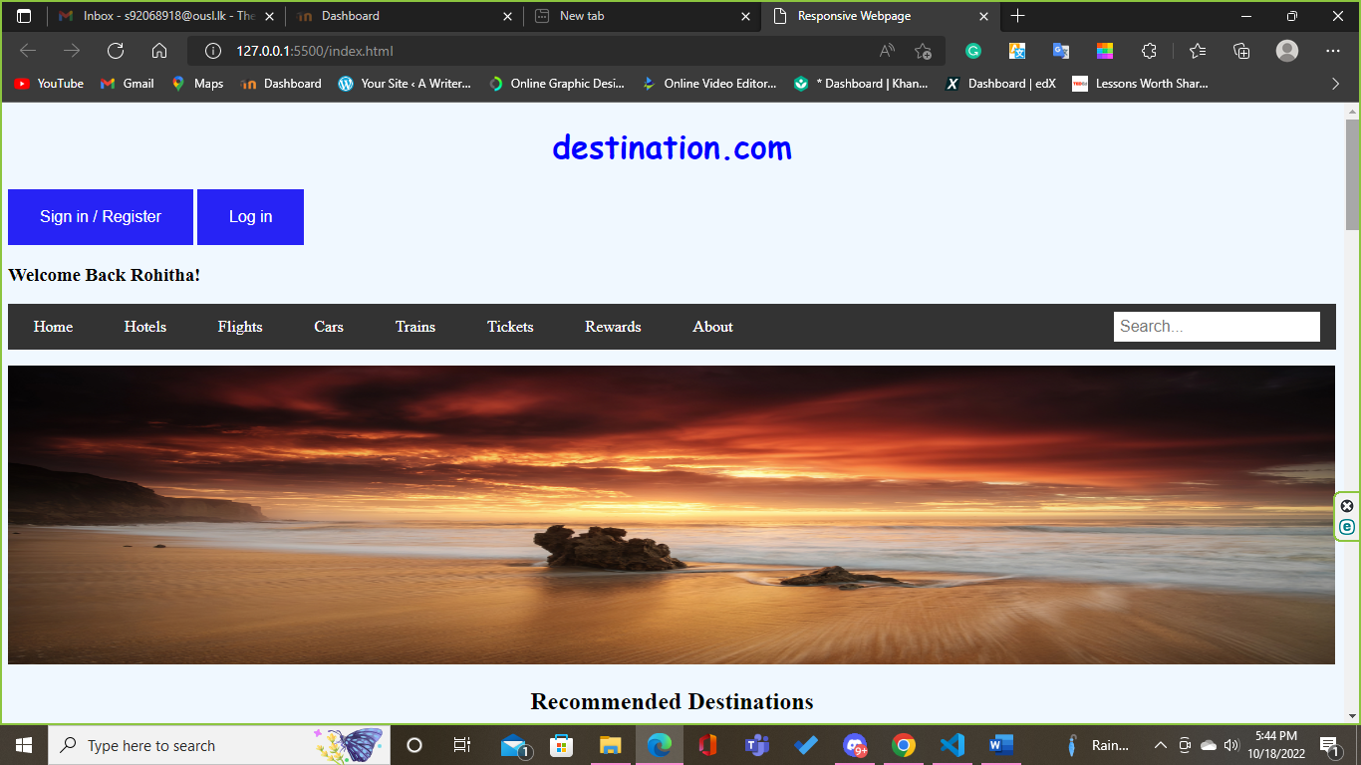

destination’s homepage immediately greets users with the destination search form they came to find, guiding them to their logical next step in their client journey. The navigation bar has eye-catching and that segment their listings into various easy-to-use categories.

The design also includes a smart search form, which auto-fills the user’s last search to minimize friction when they use the site.

Their homepage displays stunning graphics of rentals all over the world to **create urgency and inspire users** to book their destination and start traveling. Media elements—like a image right below the navigation bar—engage users to convert.

destination’s user-centric web design has helped them connect with more customers, bring in more bookings, and increase brand awareness.

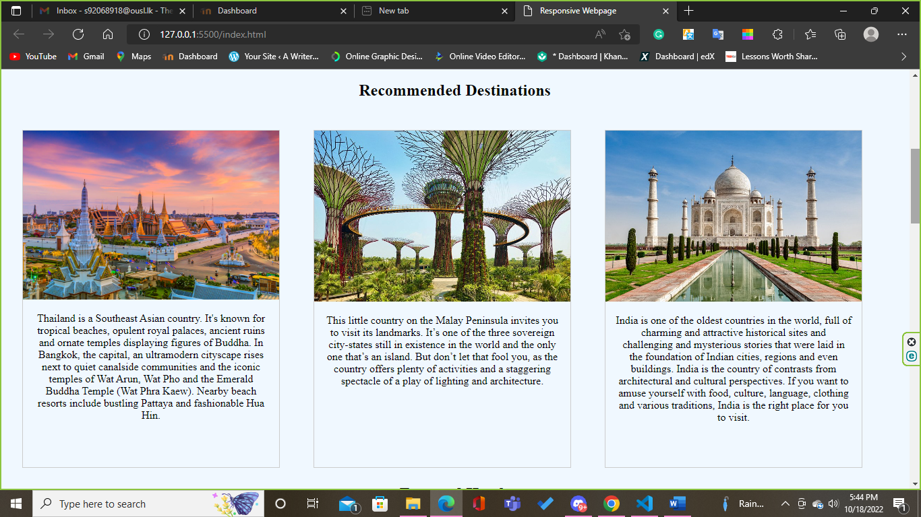

Destination’s recommended destinations are the best and popular countries featuring section. The website recommended you the present best country areas and activities

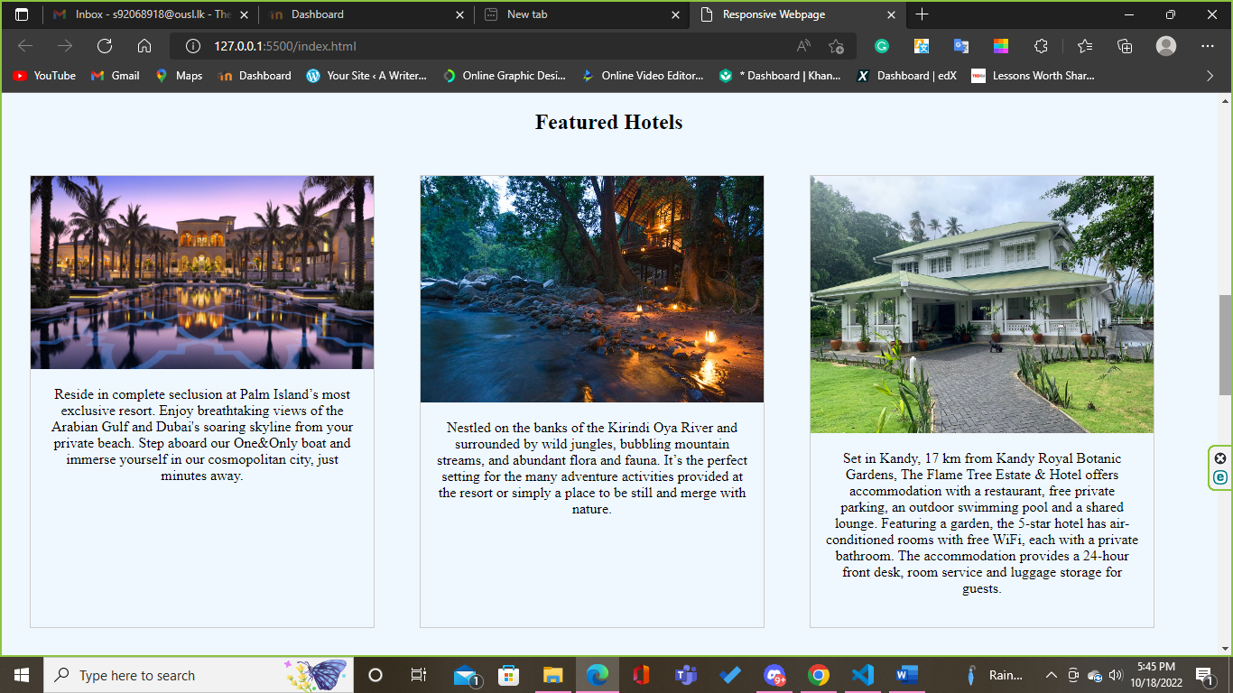

Destination’s featured hotels are the best deals and popular hotels featuring section. The website recommended you the best and beautiful hotels around the world.

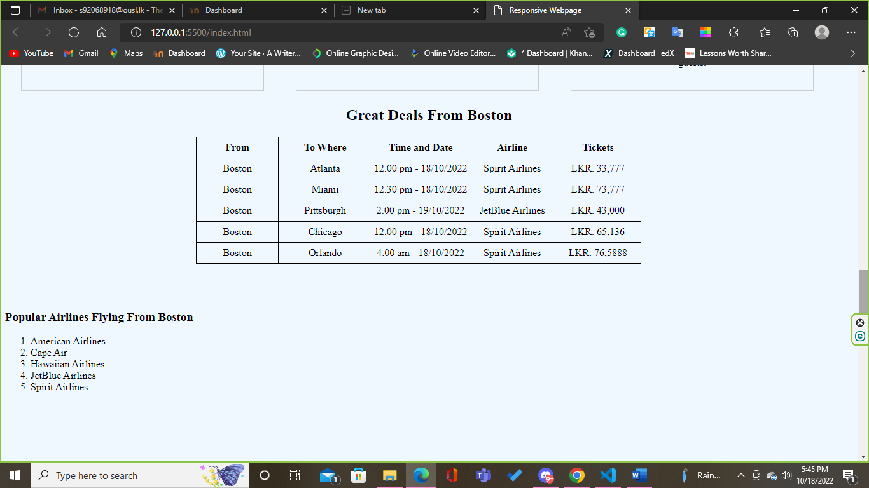

Destination.com present you, according to your location, what is the flight time-table in the cheapest airlines in your country, you can click the table and book right away!

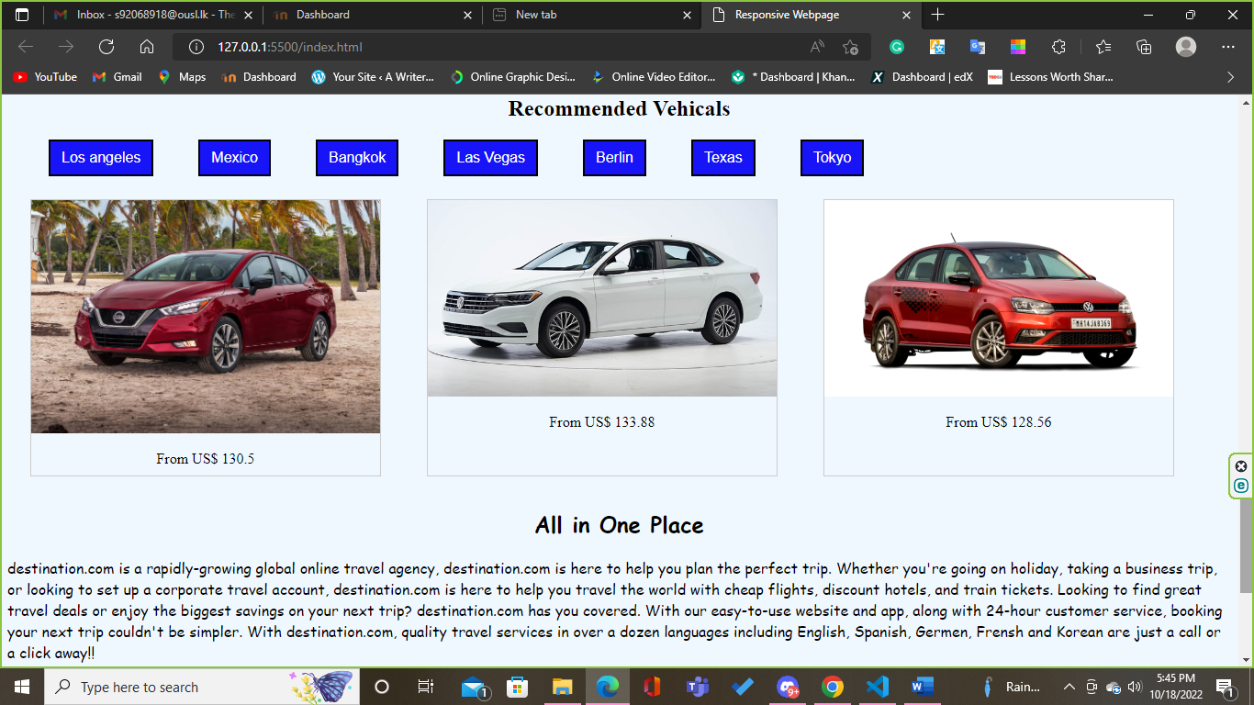

In destionation.com you can hire a vehicle too. There are multiple choices to select a vehicle. You can choice a your location above the images, and then choose according to the selected area.

**HTML CODES**

<!DOCTYPE html>

<html lang="en">

<head>

<meta charset="UTF-8">

<meta http-equiv="X-UA-Compatible" content="IE=edge">

<meta name="viewport" content="width=device-width, initial-scale=1.0">

<title> Responsive Webpage</title>

<link rel="stylesheet" href="styles.css">

<script>

function myFunction() {

document.getElementById("demo").innerHTML = "Welcome Back Rohitha!";

}

</script>

</head>

<body>

<h1 id="title">destination.com</h1>

<div>

<button class="signin" type="submit">Sign in / Register</button>

<button class="signin" type="button" onclick="myFunction()">Log in</button>

<h3 id="demo">Join Us For New Adventures</h3>

</div>

<div class="topnav">

<ul>

<li><a class="active" href="#home">Home</a></li>

<li><a href="#hotels">Hotels</a></li>

<li><a href="#flights">Flights</a></li>

<li><a href="#cars">Cars</a></li>

<li><a href="#trains">Trains</a></li>

<li><a href="#tickets">Tickets</a></li>

<li><a href="#rewards">Rewards</a></li>

<li><a href="#about">About</a></li>

<li style="float: right ;"><div class="searchbox">

<input type="text" placeholder="Search...">

</div>

</li>

</ul>

</div>

<img id="imgmain" src="img01.jpg" alt="the beach">

<div>

<h2>Recommended Destinations</h2>

<div class="gallery">

<a target="_blank" href="Thailand.jpg">

<img src="Thailand.jpg" alt="Thailand destinations" width="600" height="400">

</a>

<div class="desc">Thailand is a Southeast Asian country. It's known for tropical beaches, opulent royal palaces, ancient ruins and ornate temples displaying figures of Buddha. In Bangkok, the capital, an ultramodern cityscape rises next to quiet canalside communities and the iconic temples of Wat Arun, Wat Pho and the Emerald Buddha Temple (Wat Phra Kaew). Nearby beach resorts include bustling Pattaya and fashionable Hua Hin.</div>

</div>

<div class="gallery">

<a target="_blank" href="singapore.jpg">

<img src="singapore.jpg" alt="singapore bay area" width="600" height="400">

</a>

<div class="desc">This little country on the Malay Peninsula invites you to visit its landmarks. It’s one of the three sovereign city-states still in existence in the world and the only one that’s an island. But don’t let that fool you, as the country offers plenty of activities and a staggering spectacle of a play of lighting and architecture. </div>

</div>

<div class="gallery">

<a target="_blank" href="india.jpg">

<img src="india.jpg" alt="india taaj-mahal" width="600" height="400">

</a>

<div class="desc">India is one of the oldest countries in the world, full of charming and attractive historical sites and challenging and mysterious stories that were laid in the foundation of Indian cities, regions and even buildings. India is the country of contrasts from architectural and cultural perspectives. If you want to amuse yourself with food, culture, language, clothing and various traditions, India is the right place for you to visit.</div>

<br><br><br>

</div>

</div>

<div>

<h2>Featured Hotels</h2>

<div class="gallery02">

<a target="_blank" href="One&Only The Palm.jpg">

<img src="One&Only The Palm.jpg" alt="One and only the palm hotel in dubai" width="600" height="400">

</a>

<div class="desc">Reside in complete seclusion at Palm Island’s most exclusive resort. Enjoy breathtaking views of the Arabian Gulf and Dubai's soaring skyline from your private beach. Step aboard our One&Only boat and immerse yourself in our cosmopolitan city, just minutes away.</div>

</div>

<div class="gallery02">

<a target="_blank" href="ella-jungle-resort.jpg">

<img src="ella-jungle-resort.jpg" alt="ella jungle resort in sri lanka" width="600" height="400">

</a>

<div class="desc">Nestled on the banks of the Kirindi Oya River and surrounded by wild jungles, bubbling mountain streams, and abundant flora and fauna. It’s the perfect setting for the many adventure activities provided at the resort or simply a place to be still and merge with nature.</div>

</div>

<div class="gallery02">

<a target="_blank" href="the-flame-tree-estate.jpg">

<img src="the-flame-tree-estate.jpg" alt="the flame tree hotel in sri lanka" width="600" height="400">

</a>

<div class="desc">Set in Kandy, 17 km from Kandy Royal Botanic Gardens, The Flame Tree Estate & Hotel offers accommodation with a restaurant, free private parking, an outdoor swimming pool and a shared lounge. Featuring a garden, the 5-star hotel has air-conditioned rooms with free WiFi, each with a private bathroom. The accommodation provides a 24-hour front desk, room service and luggage storage for guests.</div>

</div>

<br><br><br><br>

</div>

<div>

<h2>Great Deals From Boston</h2>

<div>

<table>

<tr>

<th>From</th>

<th>To Where</th>

<th>Time and Date</th>

<th>Airline</th>

<th>Tickets</th>

</tr>

<tr>

<td>Boston</td>

<td>Atlanta</td>

<td>12.00 pm - 18/10/2022</td>

<td>Spirit Airlines</td>

<td>LKR. 33,777</td>

</tr>

<tr>

<td>Boston</td>

<td>Miami</td>

<td>12.30 pm - 18/10/2022</td>

<td>Spirit Airlines</td>

<td>LKR. 73,777</td>

</tr>

<tr>

<td>Boston</td>

<td>Pittsburgh</td>

<td>2.00 pm - 19/10/2022</td>

<td>JetBlue Airlines</td>

<td>LKR. 43,000</td>

</tr>

<tr>

<td>Boston</td>

<td>Chicago</td>

<td>12.00 pm - 18/10/2022</td>

<td>Spirit Airlines</td>

<td>LKR. 65,136</td>

</tr>

<tr>

<td>Boston</td>

<td>Orlando</td>

<td>4.00 am - 18/10/2022</td>

<td>Spirit Airlines</td>

<td>LKR. 76,5888</td>

</tr>

</table>

<br><br><br>

<h3>Popular Airlines Flying From Boston</h3>

<ol>

<li>American Airlines</li><br>

<li>Cape Air</li><br>

<li>Hawaiian Airlines</li><br>

<li>JetBlue Airlines</li><br>

<li>Spirit Airlines</li><br>

</ol>

</div>

</div>

<div>

<br><br><br><br>

<h2>Recommended Vehicals</h2>

<div>

<button class="vehicals" type="button">Los angeles</button>

<button class="vehicals" type="button">Mexico</button>

<button class="vehicals" type="button">Bangkok</button>

<button class="vehicals" type="button">Las Vegas</button>

<button class="vehicals" type="button">Berlin</button>

<button class="vehicals" type="button">Texas</button>

<button class="vehicals" type="button">Tokyo</button>

</div>

<div class="gallery03">

<a target="_blank" href="2020_nissan_versa_sedan.jpg">

<img src="2020_nissan_versa_sedan.jpg" alt="2020 nissan versa sedan" width="600" height="400">

</a>

<div class="desc">From US$ 130.5</div>

</div>

<div class="gallery03">

<a target="_blank" href="volkswagen-jetta.jpg">

<img src="volkswagen-jetta.jpg" alt="volkswagen jetta" width="600" height="400">

</a>

<div class="desc">From US$ 133.88</div>

</div>

<div class="gallery03">

<a target="_blank" href="volkswagen-vento.jpeg">

<img src="volkswagen-vento.jpeg" alt="volkswagen vento" width="600" height="400">

</a>

<div class="desc">From US$ 128.56</div>

</div>

<br><br><br><br><br><br><br><br><br><br><br><br><br><br><br><br><br><br><br>

</div>

<div>

<h2 style="font-family: cursive ;">All in One Place</h2>

<p style="font-family: cursive ;">destination.com is a rapidly-growing global online travel agency, destination.com is here to help you plan the perfect trip. Whether you're going on holiday, taking a business trip, or looking to set up a corporate travel account, destination.com is here to help you travel the world with cheap flights, discount hotels, and train tickets. Looking to find great travel deals or enjoy the biggest savings on your next trip? destination.com has you covered. With our easy-to-use website and app, along with 24-hour customer service, booking your next trip couldn't be simpler. With destination.com, quality travel services in over a dozen languages including English, Spanish, Germen, Frensh and Korean are just a call or a click away!!</p>

</div>

<div>

<br><br><br><br><br>

<footer>

<h3>Contact Us</h3>

<br><br><br><br><br>

<img src="facebook.png" alt="facebook icon">

<a target="_blank" href="http://facebook.com">Facebook</a>

<img src="twitter.png" alt="twitter icon">

<a target="_blank" href="http://twitter.com">Twitter</a>

<img src="instagram.png" alt="instagram icon">

<a target="_blank" href="http://instagram.com">Instagram</a>

<img src="youtube.png" alt="youtube icon">

<a target="_blank" href="http://youtube.com">Youtube</a>

<br><br>

<a target="_blank" href="destination@gmail.com">destination@gmail.com</a></p>

</footer>

</div>

</body>

</html>

**CSS CODES**

body{

background-color: aliceblue;

}

#title{

color: blue;

font-family: cursive;

text-align: center;

}

h2{

text-align: center;

}

.signin{

background-color: #2723f5; /* light blue */

border: none;

color: white;

padding:19px 32px;

text-align: center;

text-decoration: none;

display: inline-block;

font-size: 16px;

cursor: pointer;

}

button:hover {

background-color: #0b95f1; /* Green */

color: white;

}

ul {

list-style-type: none;

margin: 5;

padding: 0;

overflow: hidden;

background-color: #333;

}

li {

float: left;

}

li a {

display: block;

color: white;

text-align: center;

padding: 14px 26px;

text-decoration: none;

}

/* Change the link color to #111 (black) on hover */

li a:hover {

background-color: #0b95f1;

}

/* Style the search box inside the navigation bar */

.topnav input[type=text] {

padding: 6px;

border: none;

margin-top: 8px;

margin-right: 16px;

font-size: 16px;

}

#imgmain{

width: 1332px;

height: 300px;

}

div.gallery {

margin: 25px;

border: 1px solid #ccc;

float: left;

width: 380px;

height: 500px;

}

div.gallery:hover {

border: 1px solid rgb(43, 133, 250);

}

div.gallery img {

width: 100%;

height: auto;

}

div.desc {

padding: 15px;

text-align: center;

}

div.gallery02 {

margin: 25px;

border: 1px solid #ccc;

float: left;

width: 380px;

height: 500px;

}

div.gallery02:hover {

border: 1px solid rgb(43, 133, 250);

}

div.gallery02 img {

width: 100%;

height: auto;

}

div.desc {

padding: 15px;

text-align: center;

}

.vehicals{

background-color: #1814f8; /*blue */

border: 2px solid black;

color: white;

padding:9px 12px;

text-align: center;

text-decoration: none;

display: inline-block;

font-size: 16px;

cursor: pointer;

margin-left: 45px;

}

button:hover {

background-color: #0b95f1; /* Green */

color: white;

}

table, th, td {

border: 1px solid;

border-collapse: collapse;

width: 700px;

height: 20px;

text-align: center;

}

table{

margin-left: 300px;

height: 200px;

}

div.gallery03 {

margin: 25px;

border: 1px solid #ccc;

float: left;

width: 380px;

height: 300px;

}

div.gallery03:hover {

border: 1px solid rgb(43, 133, 250);

}

div.gallery03 img {

width: 100%;

height: auto;

}

div.desc {

padding: 15px;

text-align: center;

}

footer {

display: block;

text-align: center;

padding: 3px;

background-color: white;

color: rgb(10, 7, 7);

}

a{

text-decoration: none;

}

h1 {

animation-duration: 2s;

animation-name: slidein;

}

@keyframes slidein {

from {

margin-left: 100%;

width: 300%;

}

to {

margin-left: 0%;

width: 100%;

}

}